**Project to**

**IBM NAAN MUTHALVAN**

**APPLIED DATA SCIENCE**

**Submitted by**

Selvin Raajkumar C (911721106315)

Vinoth Raajan K  (911721106039)

Sriram N  (911721106317)

Praveen Kumar  (911721106310)

**MOUNT ZION COLLEGE OF ENGINEERING AND TECHNOLOGY**

**NAAC Accredited Institution (with A+ Grade)**

Pudukkottai-622507, Tamil Nadu.

Customer segmentation using data science

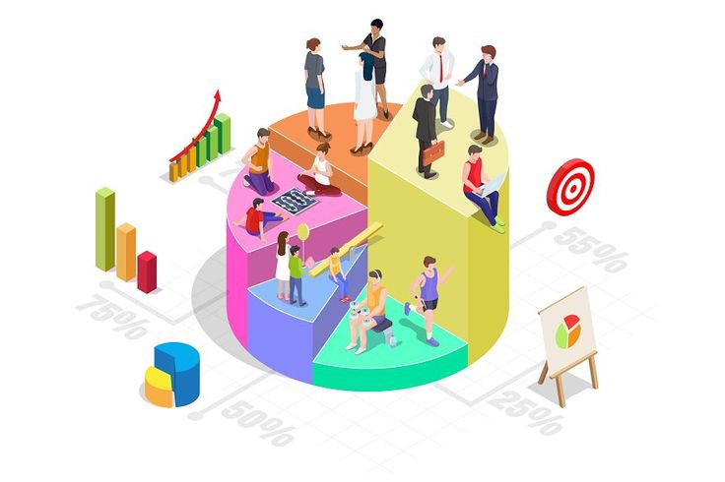

**Project title**: Customer segmentation

**Problem Statement:**

In the competitive market environment, understanding and satisfying customer needs are key to business success. However, treating all customers the same may not yield the best results, as different customers may have different needs and behaviors. Therefore, it is crucial to segment customers into distinct groups where individuals within a group are similar to each other and different from individuals in other groups.

The goal of this project is to use data science techniques to segment the customer base of a company.

**PHASE 2**: Innovation In this section you need to put your design into innovation to solve the problem. Create a document around it and share the same for assessment as per the instructions in the project.

**Abstract:**

Customer segmentation is a crucial strategy in modern business and marketing, aiming to divide a diverse customer base into distinct groups based on shared characteristics, behaviors, and preferences. This segmentation process enables businesses to tailor their products, services, and marketing efforts to specific customer needs, ultimately enhancing customer satisfaction and maximizing profitability.

**Introduction:**

In the fast-paced landscape of modern business, understanding and effectively engaging with customers is a critical factor for success. Customer segmentation, a strategic process of categorizing a diverse customer base into distinct groups based on shared characteristics, behaviors, and preferences, serves as a powerful tool for businesses seeking to tailor their products, services, and marketing efforts to meet the specific needs of various customer segments. This approach not only enhances customer satisfaction but also maximizes profitability by delivering targeted and personalized experiences.

**Key components:**

* **Data Collection:**
* **Customer Data Sources:** Gather data from various customer touchpoints, including transactions, online interactions, surveys, and demographic information.
* **Data Quality Assurance:** Ensure data integrity and accuracy through data cleaning and preprocessing.
* **Exploratory Data Analysis (EDA):**
* **Understanding Data Patterns:** Conduct EDA to identify patterns, trends, and outliers within the customer dataset.
* **Feature Engineering:** Extract relevant features from the data that contribute to meaningful segmentation.
* **Data Science Techniques:**
* **Clustering Algorithms:** Implement clustering methods (e.g., k-means, hierarchical clustering) to group customers with similar characteristics.
* **Classification Models:** Apply classification algorithms (e.g., decision trees, random forests) to identify distinguishing features of different customer segments.
* **Feature Importance Analysis:**
* **Identifying Key Variables:** Determine which features contribute most to the definition of each customer segment.
* **Dimensionality Reduction:** Use techniques like PCA (Principal Component Analysis) to reduce the number of variables while retaining essential information.
* **Segmentation Validation:**
* **Internal Validation Metrics:** Employ metrics like silhouette score for clustering algorithms to evaluate the quality of segmentation.
* **External Validation:** Compare results with external benchmarks or business domain knowledge.
* **Granular Segmentation:**
* **Fine-Tuning Segmentation:** Refine segmentation to achieve granularity, ensuring distinct and meaningful customer groups.
* **Sub-Segment Identification:** Explore sub-segments within larger segments for more targeted strategies.
* **Targeted Marketing Strategies:**
* **Personalized Campaigns:** Develop marketing campaigns tailored to the preferences and behaviors of each identified segment.
* **Recommendation Systems:** Implement personalized recommendation engines based on segment preferences.
* **Ethical Considerations:**
* **Privacy and Security:** Ensure compliance with data protection regulations and implement robust security measures.
* **Transparent Communication:** Communicate clearly with customers about data usage and seek their consent for segmentation activities.
* **Monitoring and Adaptation:**
* **Continuous Monitoring:** Regularly update and reassess customer segments based on evolving data patterns.
* **Adaptive Strategies:** Adjust marketing and business strategies based on changes in customer behavior and market dynamics.
* **Performance Metrics:**
* **Business KPIs:** Define key performance indicators (KPIs) aligned with business objectives (e.g., customer retention, revenue growth) to measure the success of segmentation strategies.
* **Feedback Mechanism:** Establish a feedback loop to incorporate insights from marketing campaigns and customer interactions.
* **Documentation and Reporting:**
* **Documentation:** Maintain comprehensive documentation of the segmentation process, including data sources, methodologies, and outcomes.
* **Regular Reporting:** Provide regular reports to stakeholders on the effectiveness of segmentation strategies and any adjustments made.

**Visualization Strategy:**

Effective visualization is crucial for conveying insights derived from customer segmentation using data science. A well-crafted visualization strategy not only aids in understanding complex patterns but also facilitates decision-making.